DentalDost Assignment

Github Repo: <https://github.com/YogeshK05/dentaldost_assignment>

Assignment is also hosted on: [yogeshk05.epizy.com](http://yogeshk05.epizy.com)

(Link may not work immediately. It takes up to 72 hrs for a new domain name to start working everywhere.)

Snapshots:

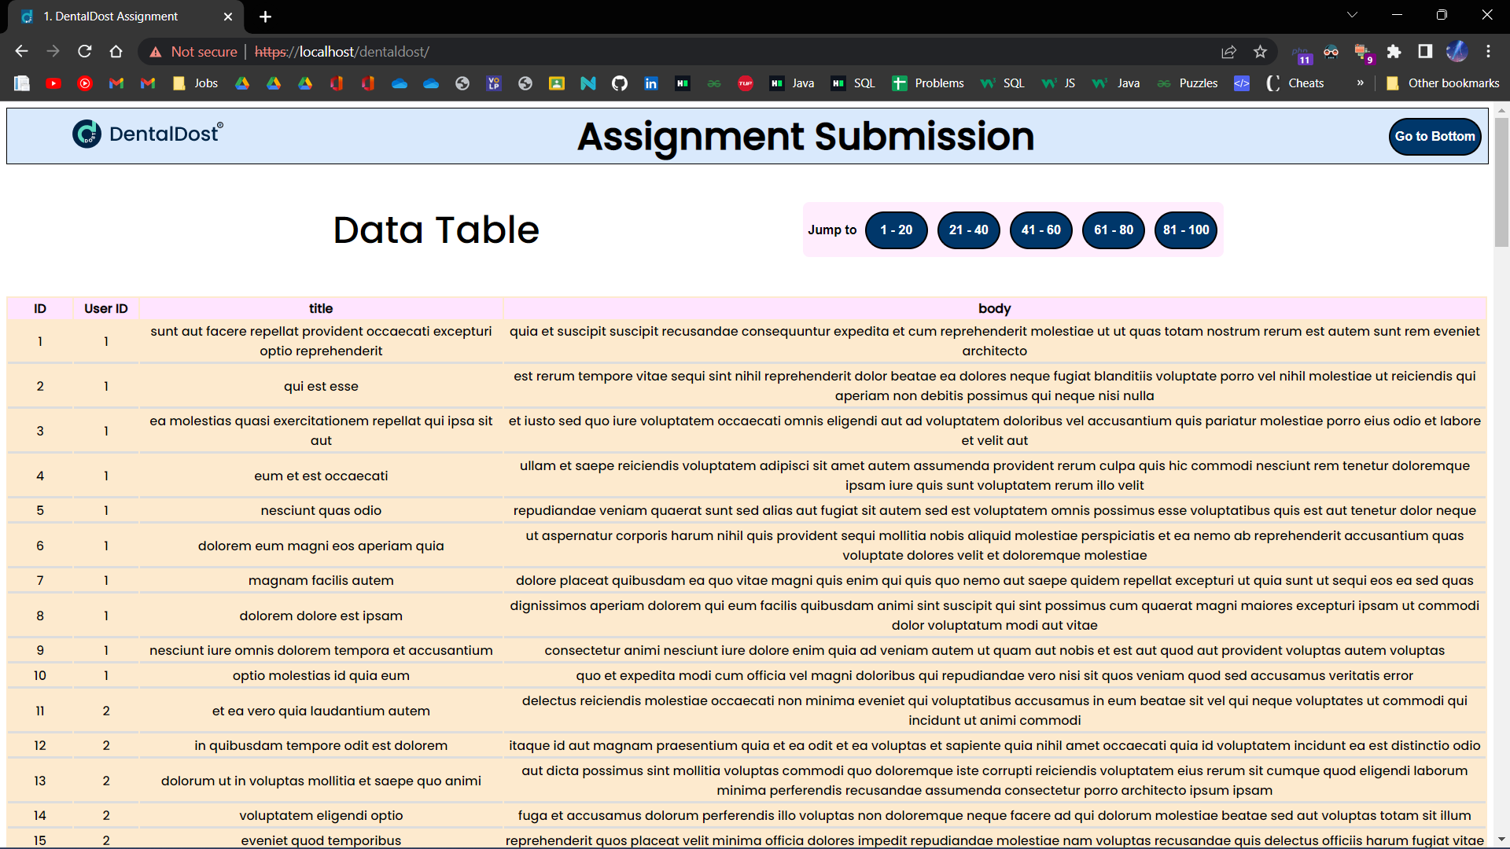

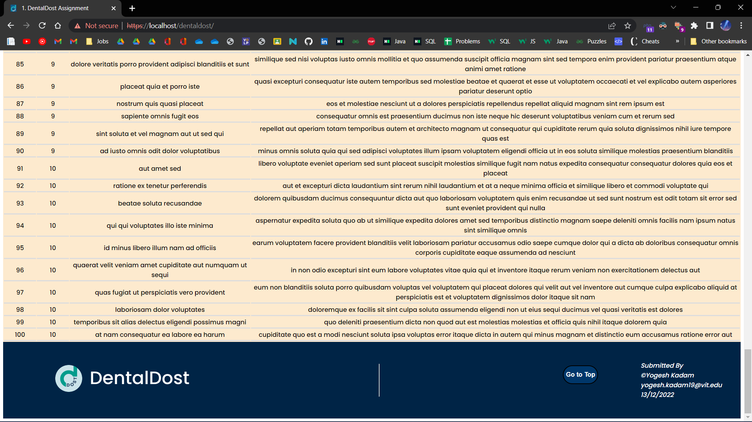

## 

## Walkthrough of the submission:

The design is taken from DentalDost’s website. Because I was instructed to work with a limited tech stack, the website is fixed in functionality. The core PHP problem statement has been solved and integrated with HTML & CSS for better visualization.

Please find the source code and snapshots of the assignment solution attached to the mail.

Section:

* Navbar

Navbar displays the company logo and heading. Also features a ‘Go to Bottom’ button.

* Middle section

It has the table title and some ‘Jump to’ links to skip to specific IDs instead of scrolling all the way down.

* Table

Table shows all of the fetched entries from the API in a proper manner.

* Footer

Footer displays the company logo along with address text to give a sense of authenticity. Also features a ‘Go to Top’ button.

Contact:

Yogesh Kadam

[yogesh.kadam19@vit.edu](mailto:yogesh.kadam19@vit.edu)

+91 9405439886